THE PROTESTANT REFORMATION
The Reformation was a religious movement which began in the first half of the 16th century and led to the division of the Christian Church and the appearance of the Protestant churches.
CAUSES
The most important causes of the Reformation were:
- The lack of training of the low clergy.
- The luxurious way of life of the upper clergy. The highest positions in the church were for the nobles and these positions were used in their own benefit what sometimes conflicted with the morals they preached.
- The church´s wealth based on their extensive lands, high taxation over the common people, and benefits from holy relics veneration.
- The sale of ecclesiastical positions with economic benefits.
- The sale of indulgences. When the church needed money, indulgences were sold. Indulgences granted the forgiveness of the sins for those who bought them.
This situation was criticized by humanists such as Erasmus of Rotterdam, but nothing was done to change it.
LUTHERANISM
Martin Luther was a German priest who criticized the corruption in the Catholic Church. He published 95 Theses in 1517 criticizing the sale of indulgences and other bad practices of the upper clergy. This was the beginning of the Protestant Reformation. The Pope made Luther retract his ideas, but he refused. So, Luther was excommunicated.
The bases of Lutheranism were:
- Free interpretation of the Bible. The Bible was translated into vernacular languages.
- Salvation does not depend on indulgences. Salvation depended on faith.
- Veneration of Virgin Mary, Saints and Holy Relics was rejected. Besides, he only accepted two sacraments: baptism and Eucharist.
- Rejection of the Church’s possessions. So, Luther supported the nobles to take over the Church´s possessions.
THE SPREAD OF THE REFORMATION
Lutheranism spread quickly in Germany, Low Countries, Denmark, and Scandinavian countries. However, new religions appeared:
- Ulrich Zwingli founded the Reformed Church in Zurich. His doctrine rejected Pope´s authority and the religious images.
- John Calvin created the Calvinism based on the theory of predestination – people were destined to salvation from the birth. Calvinism spread across Switzerland, England (Puritans), France (Huguenots), Scotland (Presbyterians), and the North of the Low Countries.
- Anglicanism emerged when the Pope did not accept the divorce of Henry VIII of England. So, he passed the Supremacy Act which created the Anglican Church whose head is the King or Queen of England.

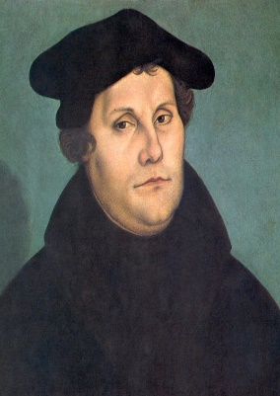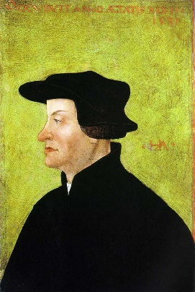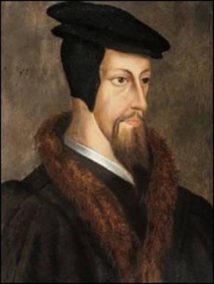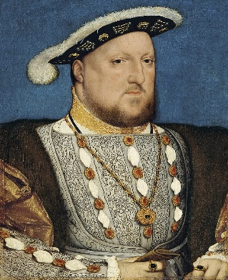

THE RELIGIOUS WARS AND
THE COUNTER-REFORMATION
THE RELIGIOUS WARS
After Luther´s excommunication, he was supported by the German nobles who wanted the properties of the Catholic Church. Carlos V, the Catholic Monarchs´ grandson, was elected Emperor in 1519 and tried to avoid the division of the Church.
The Diet of Worms confirmed the division as no agreement was made. The Protestant German princes formed the Schmalkaldic League which confronted with the Emperor at the Battle of Mühlberg. The League was defeated by the emperor although the conflict was not over. The Peace of Augsburg in 1555 granted religious freedom.
However, the Peace of Augsburg did not solve the situation, and caused religious wars:
- In France, wars between Catholics and Huguenots continued in the second half of the 16th century. The conflict finished with the Edict of Nantes signed by Henry IV which granted the Protestants religious freedom.
- In the Low Countries, the Dutch War of Independence or Eighty Years´ War (1568-1648) was a civil war between Calvinists and Catholics as well as revolt against the Spanish dominion. It finished with the independence of the Northern Provinces.
- In the British Isles, the Wars of the Three Kingdoms (1639-1651) between Catholics, Puritans and Anglicans in England, Scotland and Ireland ended with the Anglican dominance.
CONSEQUENCES OF THE RELIGIOUS DIVISION IN EUROPE
- The religious persecutions took place in all kingdoms.
- The Pope and the Emperor lost influence.
- The Protestant kings and nobles were more powerful and took over the possessions of the Catholic Church.
THE COUNTER-REFORMATION
The Counter-Reformation was the reaction of the Catholic Church against the Protestant Reformation.
The Council of Trent was held between 1545 and 1563 reevaluated the Catholic doctrine in three ways:
- The clarification of the doctrines. The authority of the Pope, the seven sacraments and the good works contribution to salvation were maintained.
- Internal Reform to finish internal corruption. Priests´ training was improved, the sale of indulgences was forbidden, and bishops were controlled strictly. The Society of Jesus created by Ignatius of Loyola improved Catholic education as well as spread the ideas of the Counter – Reformation.
- The repression of Protestantism. The Inquisition gained influence, Protestants were persecuted as heretics and an index of forbidden books was published.
However, the division in the Church could not be stopped.
