THE SPANISH HABSBURG DYNASTY
THE RELIGIOUS WARS
During the 16th century the Spanish monarchy was the most powerful in Europe. Carlos I and Felipe II reigned from 1516 to 1598 and were the two first monarchs of the Spanish Habsburg dynasty.
Carlos I and Felipe II ruled with absolute political power and their main political objectives were:
- TO MAINTAIN TERRITORIAL POSSESIONS with constant wars. Therefore, the wealth and precious metals from the Americas were spent on financing wars. Even these riches were not enough so both monarchs had to ask Italian and German bankers for loans.
- TO DEFEND CATHOLICISM, they reinforced the religious unity in two different ways:

- Their domestic policy was based on persecution of those who questioned Catholicism, humanists, and Protestants. The Inquisition prohibited books and the policy of limpieza de sangre prevented converts from occupying public positions.
- Their foreign policy was based on having religious wars against the Protestant states.16th
Administration was based on different councils continuing the Catholic Monarchs´ administrative system.
ECONOMY AND SOCIETY IN THE 16TH CENTURY

Economy flourished in the 16th century based on the riches from the Americas.
Sevilla became the most important port controlling the trade with the Americas as the Casa de Contratación was established there.
Felipe II to avoid piracy organized the fleet system consisting of a fleet of
ship escorted by warships. These are the main evidence of the impact of the precious metals from America in the Spanish monarchy:
- These metals were the main source of financing for the wars in Europe, so this wealth was transferred outside of Spain.
- The nobility used these metals to buy luxury products instead of investing in productive activities which would generate more wealth.
- Crafts grew although the rise in prices made Spanish products more expensive, then it was cheaper to import them.
- Monarchs embraced more expensive projects but as they needed more money, the result was the rise in taxes. Taxes were paid by the peasants and the bourgeoisie while the clergy and the nobles did not have to pay taxes.
- Economy based on agriculture made population vulnerable due to bad harvests.
Spanish economy declined at the end of the 16th century. Small businesses survived. Castilian wool industry and Aragonese textiles almost disappeared as the could not complete with foreign products.
The lack of production affected trade. So, there was an economic recession.
CARLOS V
THE EMPIRE OF CARLOS V
Carlos I inherited these territories:
- From his maternal grandmother, Isabel I: Castilla, Navarra, territories in America and cities in the North of Africa.
- From his maternal grandfather, Fernando II: the Crown of Aragón and the Italian territories.
- From his father, Felipe I: The Low Countries and the Franche- Comté.
- From his paternal grandfather, Maximilian I: Austria and the right to be nominated for Holy Roman Emperor.
He was appointed Holy Roman Emperor in 1519 and was known as Carlos V of Germany and Carlos I of Spain.
THE BEGINNING OF THIS REIGN
Carlos was born in Ghent in 1500 and he lived there until 1517 when came to Castile. When he was in Castile, he did not speak Spanish and he was perceived as a foreigner by the nobility.
Castilla, going through an economic crisis, suffered a tax increase to finance the election of Carlos V as a Holy Roman Emperor. This caused the revolt of the Comuneros in 1520 when the low nobility and the bourgeoisie revolted against the government. The comuneros were defeated at the battle of Villalar. Later, the leaders of the Comuneros – Juan Bravo, Juan Padilla and Francisco Maldonado – were executed.
In Mallorca and Valencia, another revolt took place. It was the Revolt of las Germanías. The local bourgeoisie and the peasants revolted against the nobility. They complained about their abuses and to improve their economic conditions. Carlos I supported the nobility and the revolt was suppressed.
After these events, Carlos I reinforced his power in Spain.
THE WARS OF CHARLES V
- AGAINST FRANCE The rivalry with France started because this kingdom was surrounded by Carlos V´s possessions. There were 4 wars between Francis I and Carlos V. The first one took place in 1525 when Francis I attacked the Duchy of Milan. Carlos V defeated Francis I at the Battle of Pavia. Later, Francis made alliances with the Pope and the Protestants to limit Carlos V´s power.
- AGAINST THE OTTOMAN EMPIRE The Ottoman Empire led by Suleiman the Magnificent attacked Vienna although the city was not conquered. In the North of Africa Suleiman was a powerful force which threatened Charles possessions in the area. Charles conquered Tunisia but he was defeated when he tried to conquer Algiers.
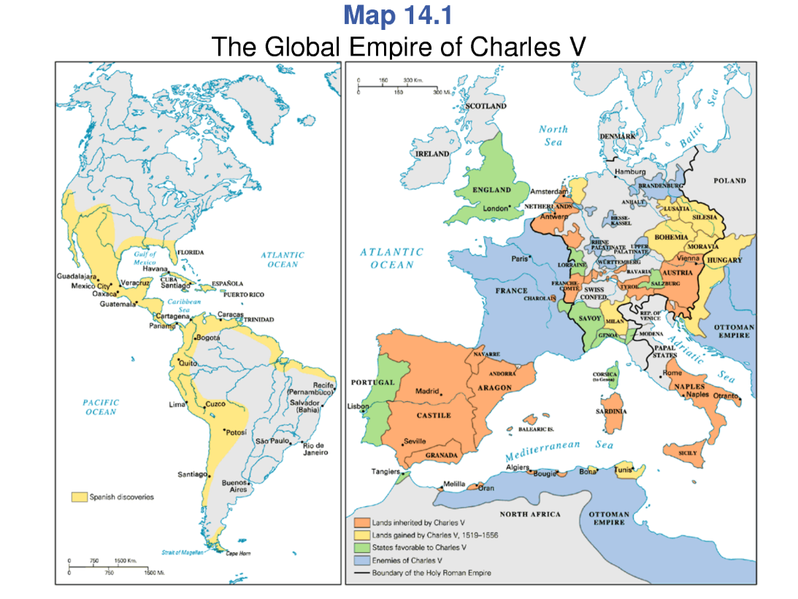
- AGAINST THE GERMAN PROTESTANT PRINCES. The Smalkaldic war between Carlos V and the Protestant princes in the Holy Roman German Empire ended with the defeat of the princes at the battle of Mülberg. The Peace of Augsburg of 1555 granted religious freedom in each part of the Empire.
