Economy in the 17th century
- Agriculture
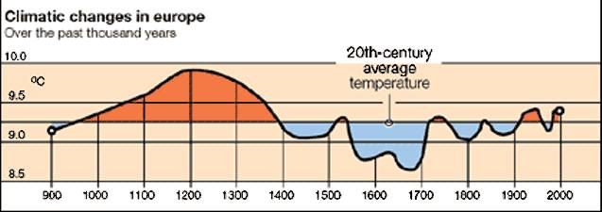

Though European climate is moderate, in the seventeenth was unusually cold. Historians sometimes call this “the Little Ice Age. Europe in the seventeenth century relied on an inefficient agriculture. Even a small deterioration in climatic conditions could have an appreciable effect in worsening the harvest and leading to famine.
Other factors that contributed to the decrease of the agriculture were:
- Wars
- Plagues which increased mortality and reduced the agricultural workforce.
- Farmers emigration to cities to avoid taxes.
- Use of inefficient techniques.
The effects of the reduction of agricultural production were the price increase and the subsistence crisis which led to demographic decline. In the second half of the 17th century, some countries implemented more efficient agricultural systems. This resulted in a population growth.
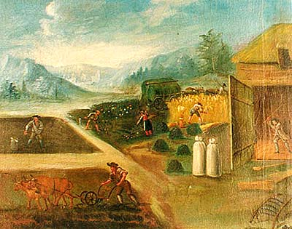
- Colonial trade
Long-distance trade in the Atlantic, the Indian and the Pacific was pioneered by the Spanish and Portuguese. In the seventeenth century, these routes became increasingly important, and the Spanish and Portuguese encountered competition from the French, Dutch, and the English. These countries also built their own empires.
Though Europe’s economic center of gravity shifted northeast to the Atlantic in the seventeenth century.
The Netherlands and England implemented the chartered companies based on monopolies in products or areas.

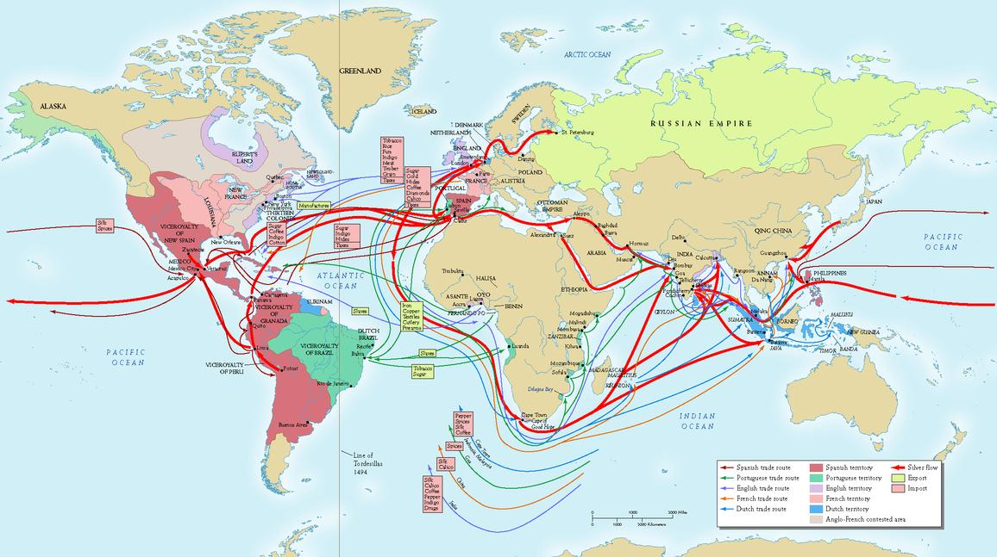

- Textile industry
Textile industry improved due to the domestic system, and it developed in England and Holland.
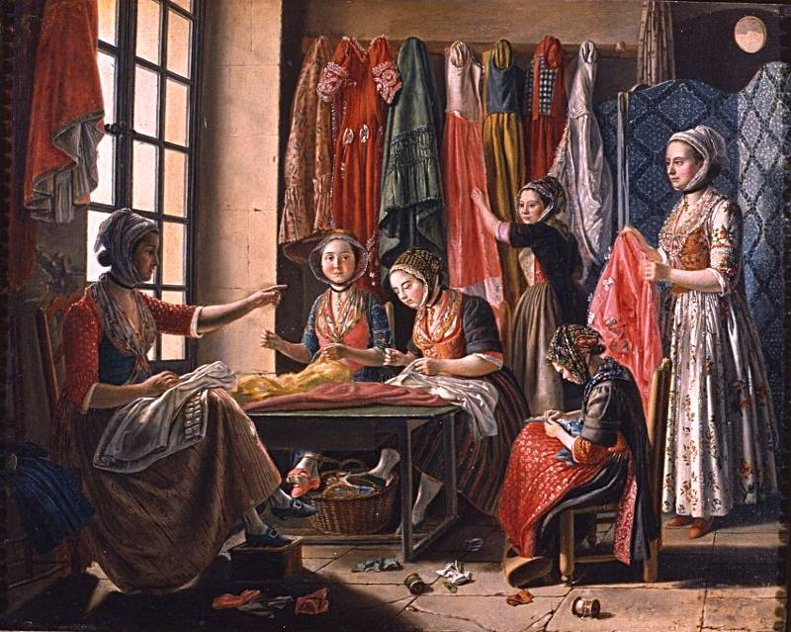
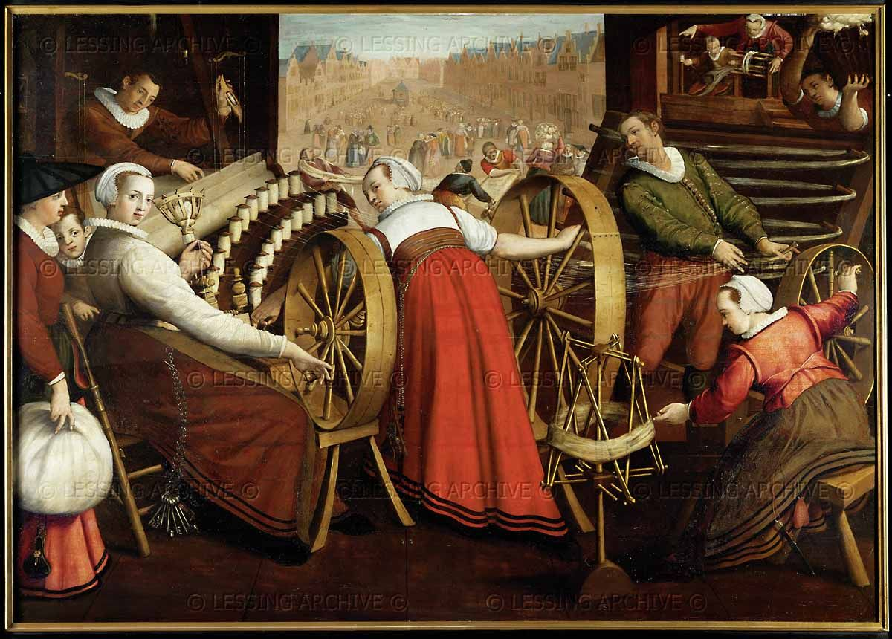

- Financial capitalism

Financial capitalism developed as trade did. Loans, chartered companies and companies with shareholders, and the emerging stock exchange markets contributed to the expansion of trade and economy.
Monarchs implemented mercantilist policies to make their countries wealthier. Mercantilism was based on:

- Increasing the number of precious metals in their countries.
- Protecting national industries by taxing imported products.

