THE THIRTY YEARS WAR (1618-1648)
The Thirty Years War was caused by conflicts between Catholics and Protestants in the Holy Roman Empire although it also had political causes such as the rivalry between France and the Habsburg dynasty ruling in Spain and the Holy Roman Empire.
These are the stages of the war:
- PROTESTANT UPRISING IN BOHEMIA In the Duchy Bohemia, the Catholic authorities were deposed by Protestant nobles who had organized a revolt. The Emperor Ferdinand II (from the Habsburg dynasty and a Catholic) fought against the Protestants.
- TWO SIDES WERE FORMED: The emperor had the support of German Catholics and the Spanish Habsburgs while the German Protestants made an alliance. The Protestants were defeated.
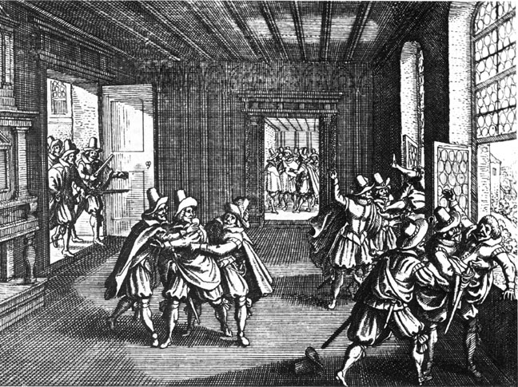
- THE INTERVENTION OF DENMARK The Lutheran king of Denmark with the support of England decided to participate in the war supporting the Protestants. On the other hand, the United Provinces restarted the war with Spain fighting for their independence. Protestants were defeated and signed the Surrender of Breda (1626)
- SWEDISH PARTICIPATION Catholics took Protestant´s possessions. The Swedish King participated in the war. This established a balance of power with resulted in a peace treaty which granted religious tolerance and the return of the confiscated properties to the Protestant.
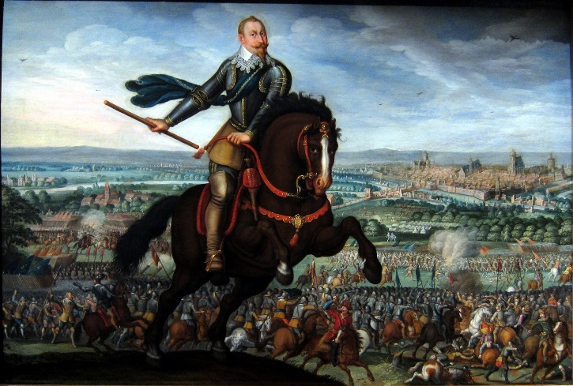
- FRANCE ENTERS THE CONFLICT France was a Catholic country surrounded by Habsburg territories, so they joined the Protestant alliance against the Catholic side. The French defeated the Spanish in the at the Battle of Rocroi in 1643.
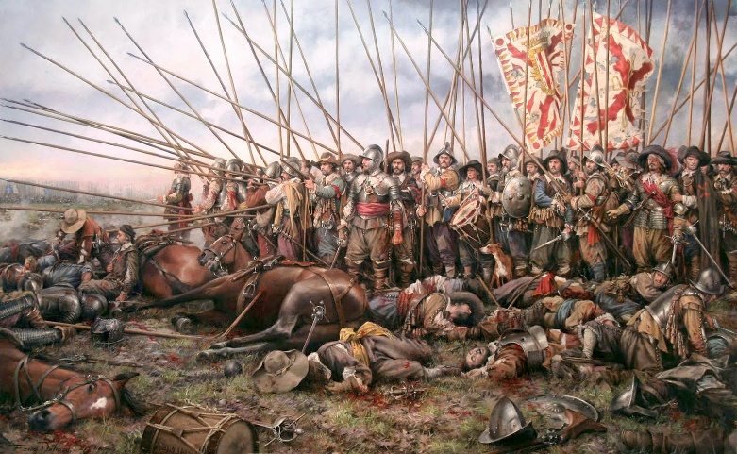

The war was devastating, then the European countries involved in the Thirty Years War decided to sign the Peace of Westphalia in 1648. The main consequences of the treaty were:
- The Spanish Monarchy lost its dominance over Europe. Spain had to recognize the independence of the United Provinces (Holland) The Dutch became a great economic power controlling commercial routes in Asia. Spain and the United Provinces signed the Treaty of Münster.
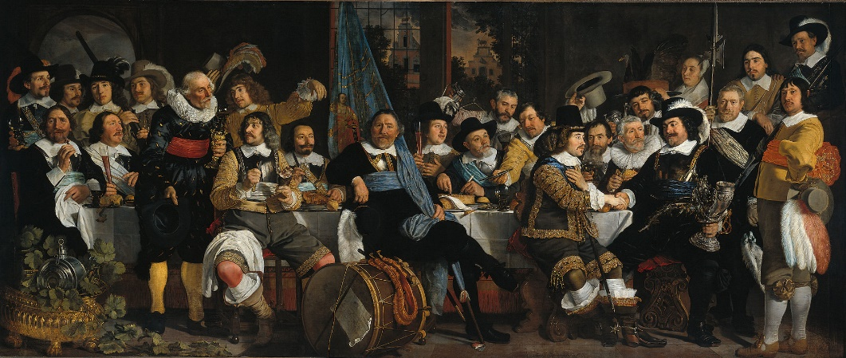
- Religious tolerance and limits to the Holy Roman Emperor were established.
- Sweeden turned into the main political power in the Baltic area.
- France got territories from the Holy Roman Empire and became the leading power in Europe.
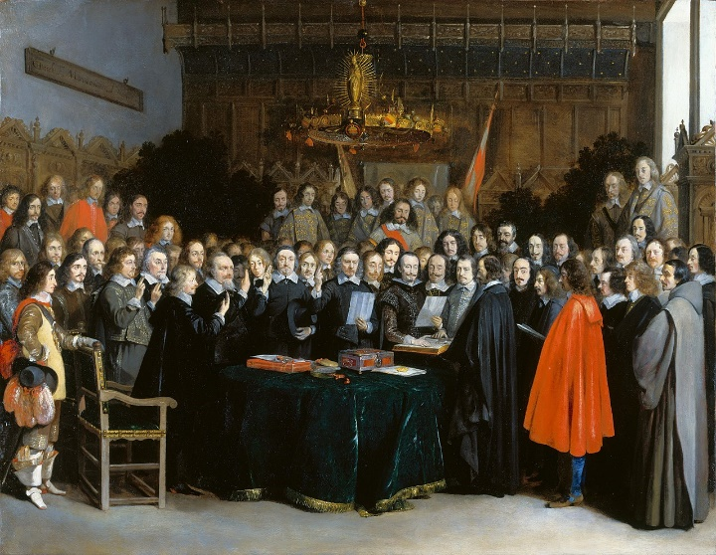
However, war between France and Spain continued for the rest of the century.

