RENAISSANCE ART IN SPAIN
- This portrait of Charles V victorious at Mühlberg is very famous. Look at the picture and answer:
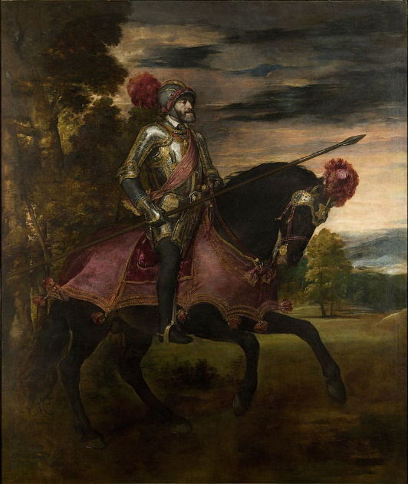
- Why do you think Charles V commissioned Titian this painting? What does it commemorate?

- How is Charles V shown? What elements in the picture empathize Charles V power?

- What of these characteristics are shown in the painting and where can we see them?
Perspective
Use of bright colors
Balance and proportion
Interest in human body
Details and realism
Interest in landscape

- Manierism was the last stage in Renaissance art. It is considered a transition between Renaissance and Baroque as it reflects reality as it is. El Greco- born in Crete- spent his adulthood in Spain. The Burial of the Count of Orgaz is one of his most famous works. Look at the picture and answer:
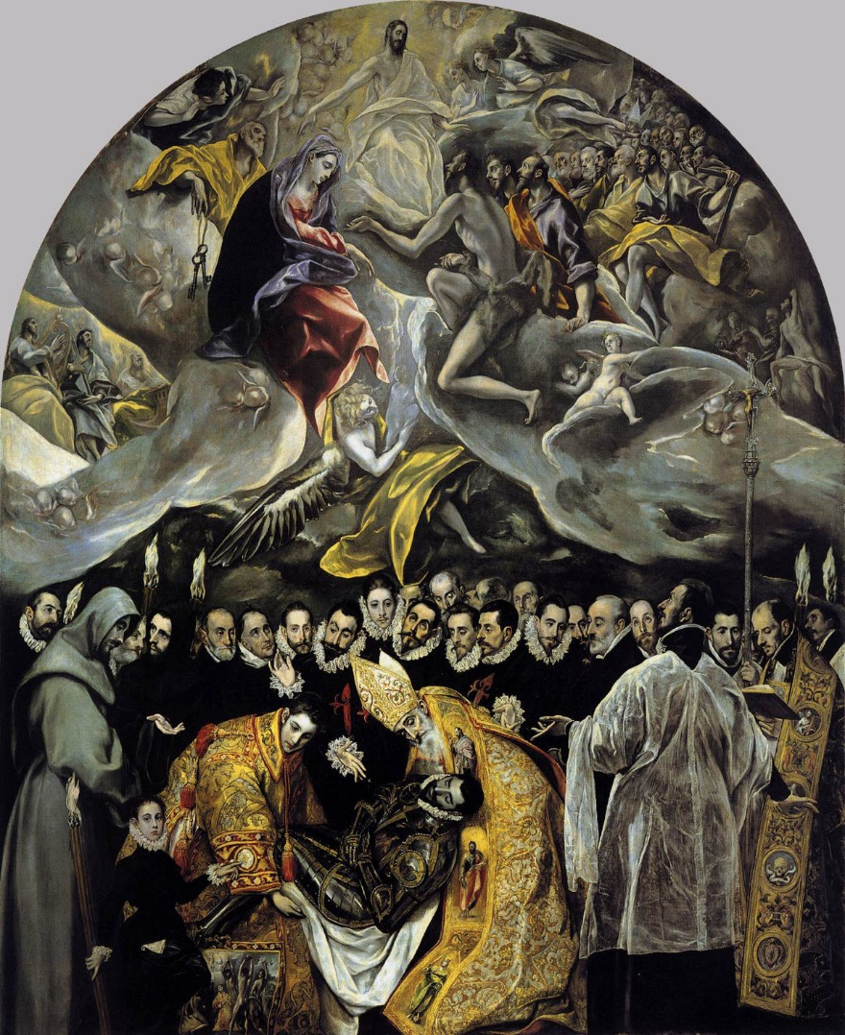
- What is represented in the painting?

- What of these characteristics can be seen in the picture? Where can you see them?
Perspective
Use of bright colors
Balance and proportion
Interest in human body
Details and realism
Interest in landscape

- Compare this painting with the one of the previous exercise and list similarities and differences.

