Name:________________________________ Date:_____________________ Hour:_______________
Section One: What is Economics?
Directions: The first step is to fill in the left column with the missing terms. Then, match each of the following concepts with the appropriate definition by writing the definition’s letter next to the concept.

___________ Scarcity | - People with all their efforts, abilities and skills
___________ First question in economics | - The tools, equipment, machinery, and factories used in the production of goods and services
___________ Need | - Land: these are the “gifts from nature’ or natural resources
___________ GDP | - Something we would like to have but is not necessary for survival
___________ Factors of production….  [list the four factors below] | - Condition that is created by people’s seemingly unlimited wants and relatively limited resources
___________ 1. | - Study of how people try to satisfy their wants through the careful use of scarce resources
___________ 2. | - What to produce
___________ 3. | - A basic requirement for survival like foods, shelter, clothing.
___________ 4. | - From whom to produce
___________ Study of Economics | - Resources required to produce the things we would like to have
___________Second question in Economics | - Gross Domestic product- the dollar value of all final goods, services, and structures produced within a country’s borders in a 12-month period
___________Want | - Risk takers in search of profits who start a new business or bring new products into the market.
___________ Third question in Economics | - How to produce

Critical Thinking: Answer the following two questions on the back of this worksheet.

- How can studying economics help us make better choices about how to use scarce resources?
- What are some resources you have noticed in your community or from around the world that are scarce? How has scarcity affected you life? Provide examples of things you or your family might have had to do without.

- Fill out on the “Applying Economics Worksheet: Factors of Production”: Pick a type of business [i.e. Gas station, restaurant, library, book store, pizza shop, ice cream store]. Using the FOUR factors of production, make a list of the things you would need for each of the factors for the business you picked. [I.e. If you picked a book store, your labor would be research assistant, book keepers, cashiers, managers, someone to stock the shelves.]

Applying Economics Worksheet: Factors of Production
Type of Business you picked: _______________________

Land | Labor | Capital | Entrepreneurs

Directions: There are four factors of production: land, capital, labor, and entrepreneurs. For each of the following pictures, write the letter for the factor of production that best fits.
A: Land
B: Capital
C: Labor
D: Entrepreneurs
  Land |  |   She teaches
  He owns a clothing business |  |   Forest
  Miner |  |   Sewing Machine
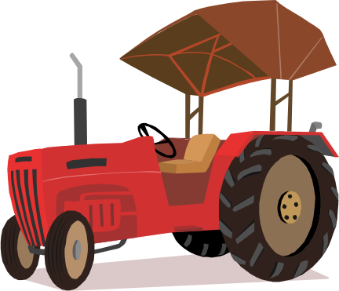  Tractor machine |  |   She owns a restaurant business

