Where Do We All Go?
With billions of people going on holiday every year there is bound to be a ranking of most popular destinations. With the clues below right the names of the top ten country destinations:

- _______________ = Home to the Eiffel Tower
- _______________ = Famous for bull-fights
- _______________ = Famous for fast food
- _______________ = Renowned for its fashion
- _______________ = Largest in population
- _______________ = Famed for fish and chips
- _______________ = Vienna is its capital
- _______________ = Most tourists visit Cancun
- _______________ = Famous for salami
- _______________ = Famed for its maple syrup

Colour and label these countries on the map below:

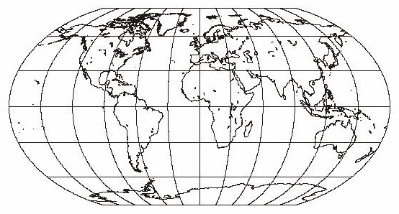
Describe the patterned layout of these countries:
__________________________________________________________________________________________________________________________________________________________________________________________________________________________________________________________________________________________________________________________________________________________________________________________________________________________
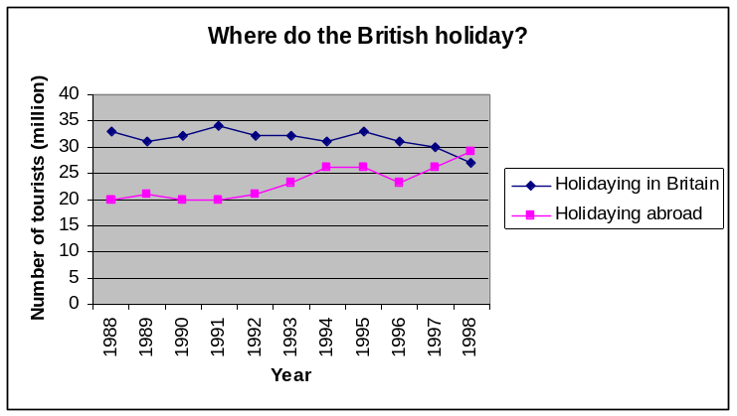
Study the graph below. Why do you think there has been a change in trend of our holiday habits?

How Has Our Holidaying Changed?
Read through the statements below and match then to the year you think they happened:

The creation of the National Railway system helped ordinary people travel. Most holidays were day trips to the British seaside by train.
The airline industry expanded and tour operators started to offer very cheap package holidays top Spain or ‘last minute’ cheap fares. Large numbers of UK residents started to go abroad for their holidays. The package holiday boom started.
Most Britons started to take a short summer holiday for a week. Camping and holidays in caravans became popular in the 60s as people started to buy cars. British holiday camps were popular.
A second yearly holiday became possible with more and more cheap packages. Holidays to Australia and more exotic locations became cheap enough for many ordinary working people.
Skiing holidays were starting to become popular and the package industry continued to expand. British tourists started to prefer a package holiday abroad to an expensive British holiday.
Most workers get at least four weeks paid holiday, plus Bank Holidays
Ordinary working people only had holidays on ‘holy’ days (Sundays, Christmas, Easter)
Packages to the USA become much cheaper than trips to British resorts. Most ordinary people went abroad.
A law was passed giving working people four days holiday unpaid. These were the first Bank Holidays
1800 - 1850
1950 - 1900
1900 – 1960s
1970s
1980s
1980s – 1990s
1990s - 2007
1871
2010

Which factor do you think has made the biggest change in how we holiday? Explain why:
______________________________________________________________________________________________________________________________________________________________________________________________________________________________________________________________________________________________________________________________________________________________________________________________________________________________________________________________________________________________________________________________________________________________________________________________

