THE GREAT EXPLORATIONS: CAUSES
In the 15th advances in navigation made expeditions across the Atlantic Ocean and the African coasts. Spanish and Portuguese monarchs financed these expeditions.
FACTORS THAT ENABLED THE EXPEDITIONS
- ECONOMIC INCENTIVES
After the fall of Constantinople in 1453, trade routes with East Asia were cancelled. Spices were in great demand, so Europeans found new routes to reach Asia since this trade was very profitable.
- IDEOLOGICAL INCENTIVES
Explores were considered as great adventurers because joining these expeditions to unknown territories were dangerous and risky. Their goal for participating in such expeditions were to make money, spreading Christian religion or finding legendary kingdoms.
Marco Polo´s book, The Book of the marvels of the world, describing travels to the Middle East and Asia exerted a major influence on sailors.
- TECHNICAL INNOVATIONS
Technical advances made possible these expeditions:
- Compass, astrolabe and sextant improved navigation and orientation.
- Portolans or maps showing ports enabled a more accurate navigation
- New ships adapted to the oceans. Three new types of ships were introduced: The carracks with three masts, the naos with three masts and square sails and the caravel. These ships enabled long distance sailing.
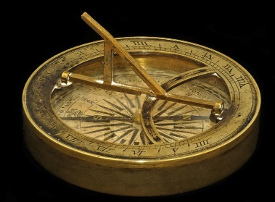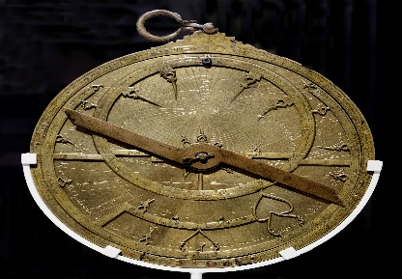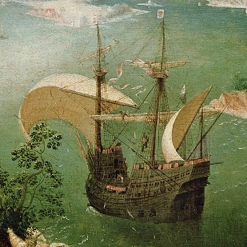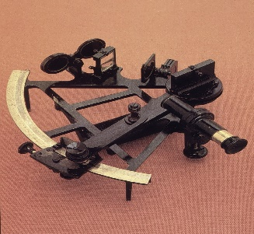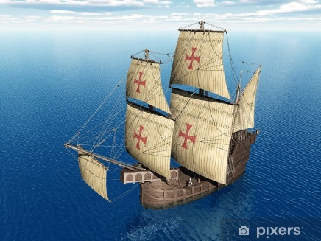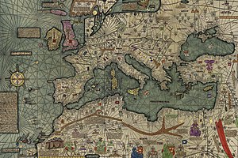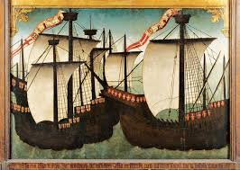

FACTORS FOR GEOGRAPHICAL DISCOVERIES
- Desire for wealth and power. (Gold and Glory)

¬ European explorers hoped to find riches in distant countries and to discover a sea route to Asia.
¬ Search for spices (nutmeg, ginger, cloves, cinnamon, pepper, etc.) and luxury goods (silk, gold, silver, jewels, ivory, porcelains, tea, etc.) from Africa and the East.

- Religious aims (God)

¬ Europeans hoped to spread Christianity to people throughout the world and to drive Muslims out of other lands.

- Renaissance spirit

¬ Europeans adventurers wanted to test the limits of human ability and to explore the unknown. Discover far away places and settle in the new lands.

- Improvements in technology

+ Europeans began to build stronger, faster sailing ships: the caravel, a ship with two sails one each for running with the wind and for sailing into the wind.
⎫ The hull design was improved and could ride out ocean storms.
⎫ They could also put canons on the decks of these ships).

+ They developed better navigational instruments:
- astrolabe, could tell north and south of the equator by the position of the stars

- magnetic compass, told direction accurately

- more accurate maps with the discovery of how to find the longitude.

