Absolute monarchy
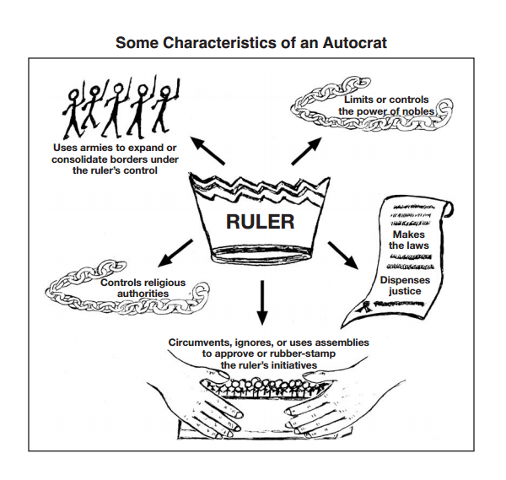
Time Period: ____________________

- How would you define “autocrat” –

- How does an autocratic ruler maintain his or her power?

Definition of Absolutism:

Definition of “Divine Right Theory”

Strengths & Weaknesses of Absolute Monarchies
Strengths | Weaknesses

How did Absolute Monarchs Increase their Power?
Politically | Socially | Economically
Other words associated with Absolutism:

