THE SPANISH SOCIETY IN THE 17TH CENTURY
The society in Spain during the 17th century did not differ much from the one in the 16th century. However, there were changes in each social group because of the economic crisis.
The Spanish society was divided into three main estates or social groups.
- The clergy was a privileged group as they did not pay taxes. It was divided into upper clergy and lower clergy.
The difference with the rest of Europe was its large number because the Catholic Church was immensely powerful in Spain.
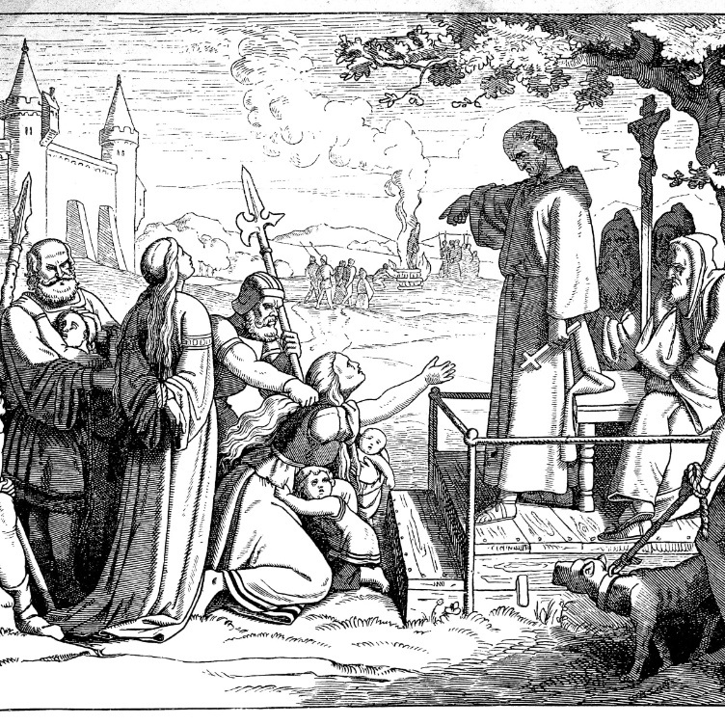
- The nobility was the other privileged group which also did not pay taxes. It was made up of two different groups:

- Higher nobility accumulated political power and lived on the rents of their lands. Their status was maintained.
They did not lose economic power because there was the mayorazgo law which granted all the land for the firstborn son.
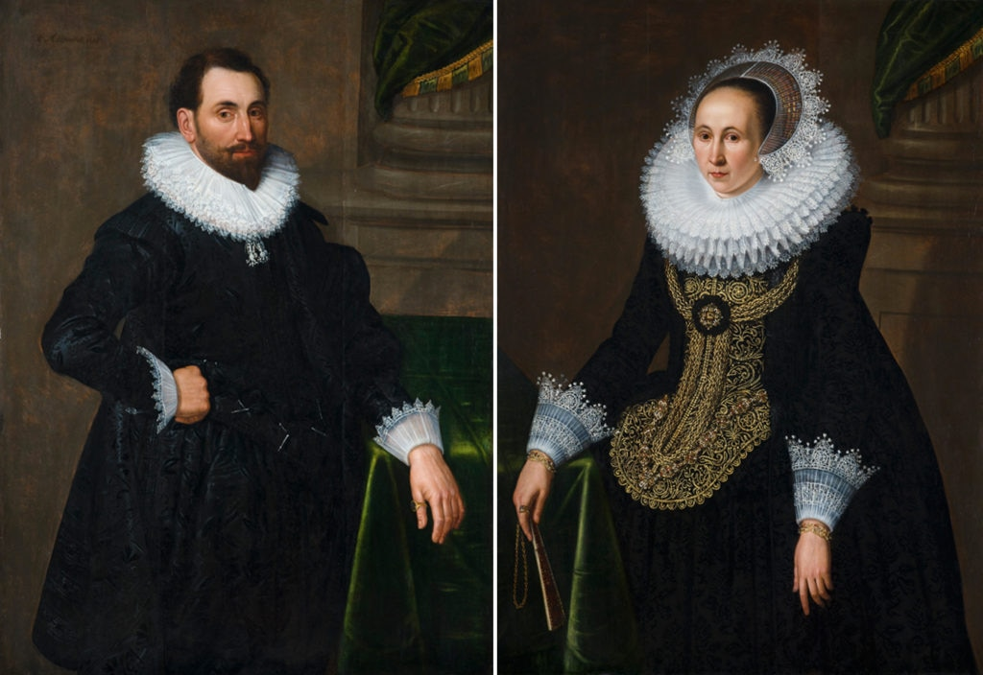
- Lower nobility experienced an impoverishment. The hidalgos enjoyed the privilege of not paying taxes but lacked income. With the medieval mentality, they rejected the manual work that was considered typical from the unprivileged social groups.
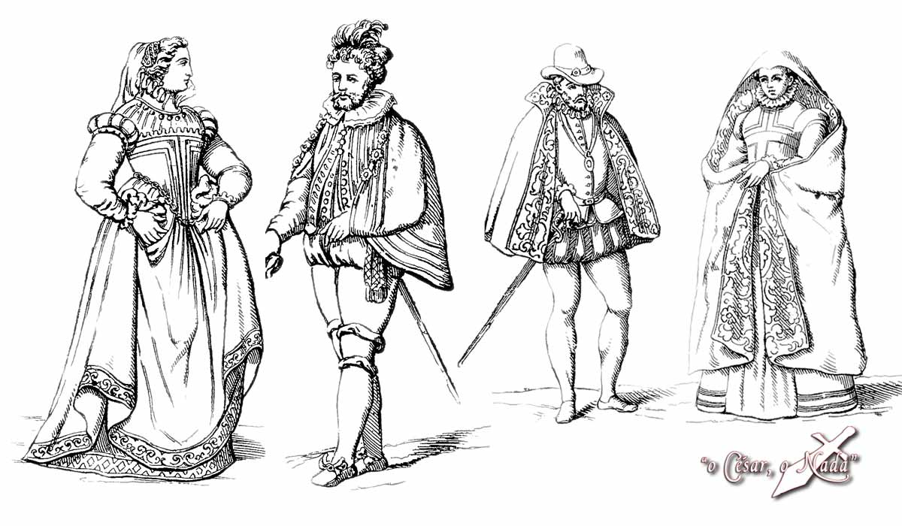
- The pecheros were those social groups who paid taxes. This group consisted of the bourgeoisie, the craftsmen, and the peasants.
- The bourgeoisie was not very numerous due to the lack of craft and trade industries.
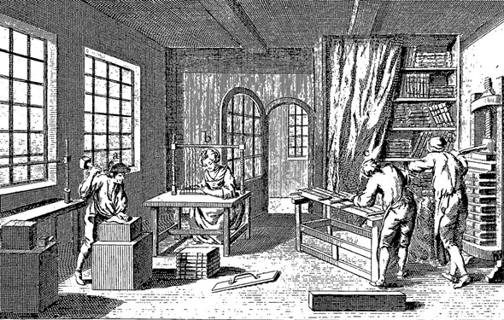
- The artisans and servants. The artisans worked for the guilds and trades went into decline because the products were not competitive. The guilds were a kind of monopoly which limited the production and the prices.
The servants worked for the nobility and bourgeoisie. Their living conditions were very harsh.
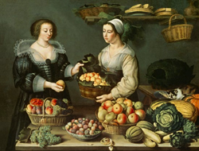
- The peasants suffered the effects of the crisis. Those who had land sold it to the nobility. Many latifundios were created. Others became bandits. The expulsion of the Moriscos, left lands without cultivating, but the condition of the peasant worsened due to the high taxes they were supposed to pay.
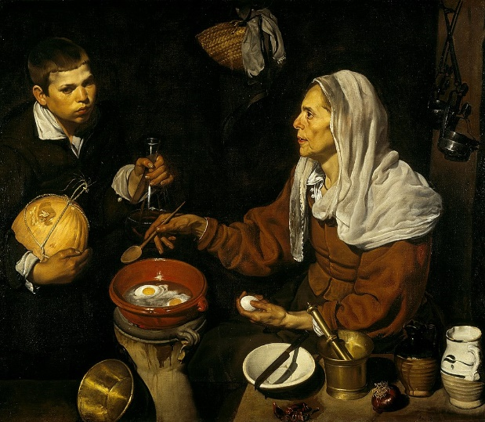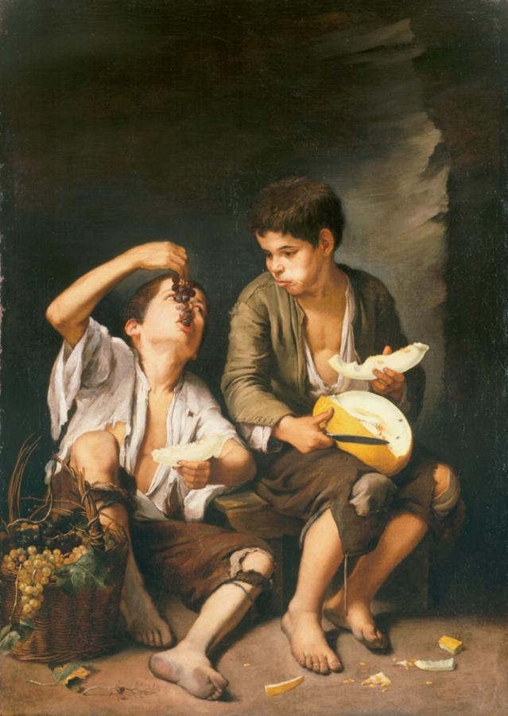
- The beggars and picaros. Their number increased due to the economic crisis. They lived on charity (sopa boba) without working.

