ABSOLUTISM IN FRANCE: LOUIS XIV
At the beginning of the 17th century, monarch in Europe accumulated more power. Then the concepts of absolute and divine right monarchies appeared.
Divine right means that the king´s authority derived from God, so their power could not be controlled by people or Parliaments, only by God. Absolute monarchy, or absolutism, meant that the ultimate authority to run a state was in the hands of a king who ruled by divine right.
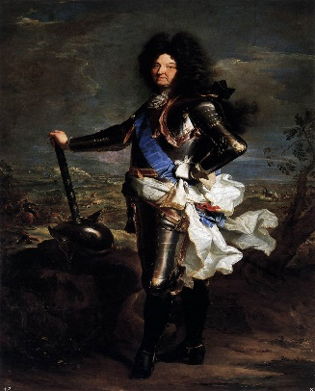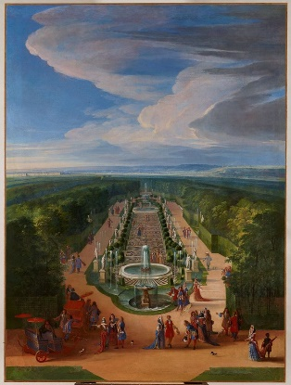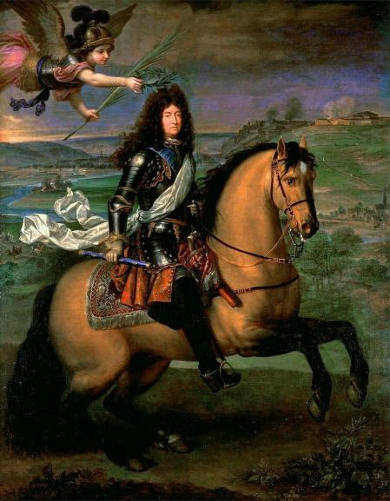
King Louis XIV of France was the best example of an absolute monarch who reigned over 72 years. The main characteristics of his administration were:
- His power to make laws was limitless.
- He appointed a large court of advisors.
- Louis XIV increased the administration to enforce his decisions as well as the administrative official from the bourgeoisie had a professional status
- He extended his diplomatic network abroad.
- He sponsored art and built the palace of Versailles to show his power and influence.
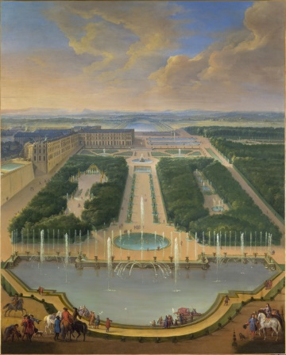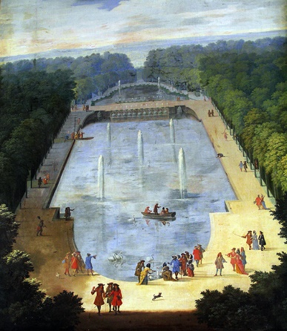
- Louis XIV had a professional army which he equipped with modern weapons while building new defensive fortresses.
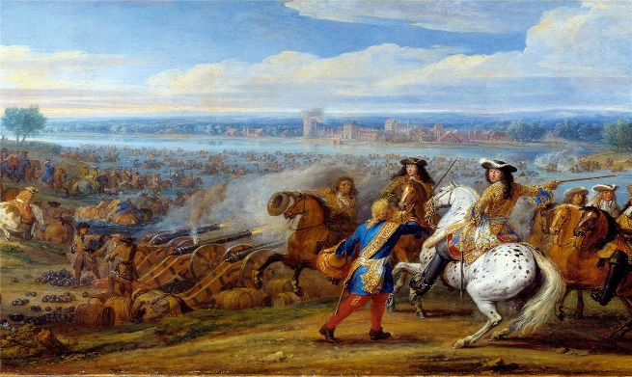
- Louis XIV appointed Colbert as Prime Minister of State to control the economy – following principles of mercantilism- and implemented the royal workshops.
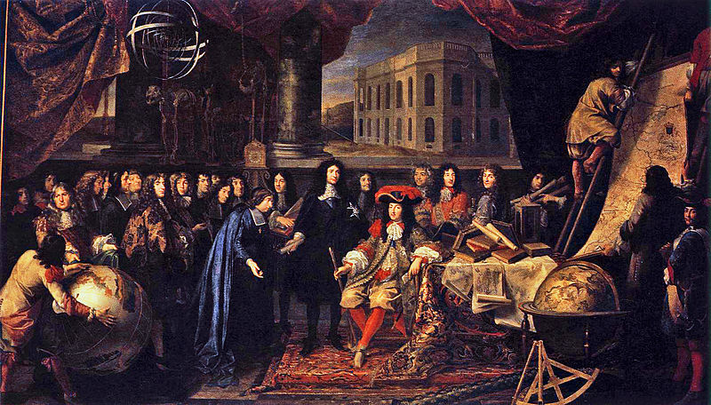
Thinkers such as Bossuet and Hobbes theorized in favor of absolutism. Bossuet was a strong advocate of divine right of kings. He thought that kings received their authority from God. On the other hand, Hobbes promoted monarchy as the best form of government to guarantee social peace.
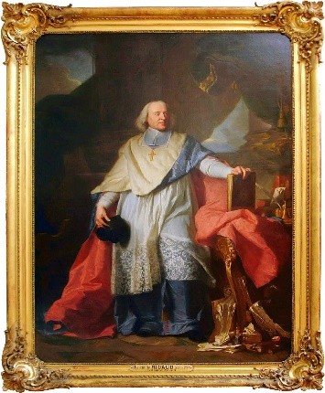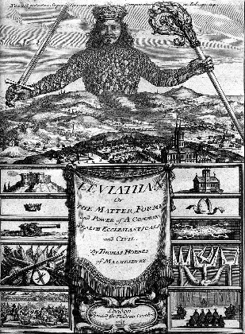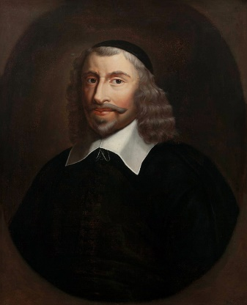
PARLIAMENTARY MONARCHY IN ENGLAND
King Charles I ruled England as an absolute monarch. He needed to increase taxes, something that should be approved by the Parliament. The Parliament agreed with the condition of limiting the king´s powers.
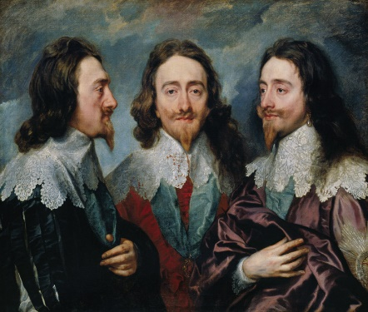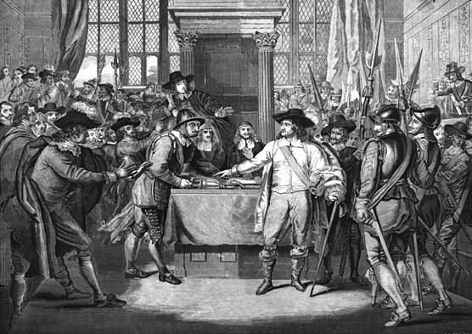
The civil war between parliamentarians and absolutists started in 1642 and it ended in 1648 with the parliamentarian victory. Charles I was executed, and England became a republic led by Oliver Cromwell. Cromwell became a dictator ruling until his death.
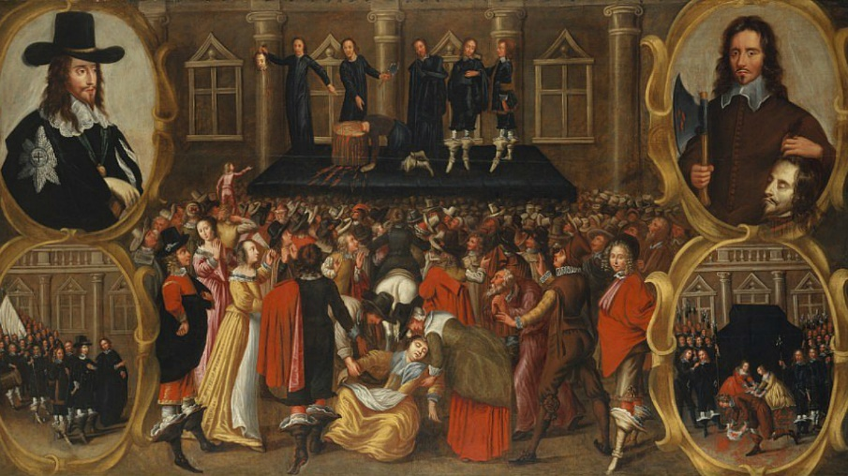
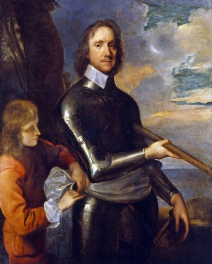
However, the monarchy was restored in 1660. King James II tried to reestablish Catholicism as the official religion. Then a revolt known as the Glorious Revolution started in 1688. The Parliament expelled James II and offered the crown to William of Orange, married to James II´s protestant daughter, Mary.
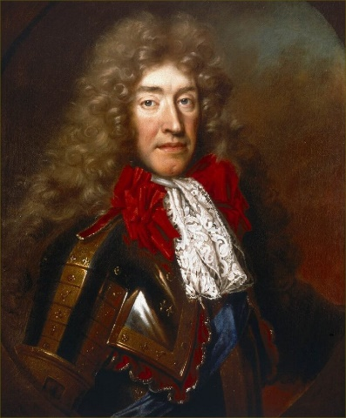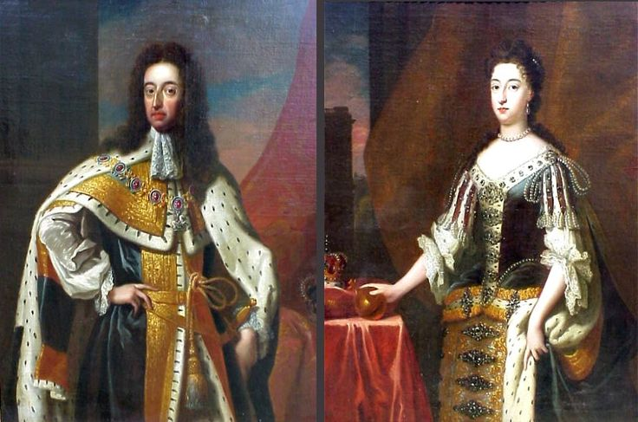
To gain access to the throne, William and Mary had to accept the Bill of Rights in 1689. The Bill of Rights limited the power of the king and recognized the private property.
England was the first parliamentary monarchy limiting the king´s power. The Parliament consisted of two chambers:
- The House of Lords representing the high nobility.
- The House of Commons defending the interests of the wealthier bourgeoisie.
Although some positions were elected by the citizens, we can conclude the parliamentary monarchy is not a democratic system because only the nobles and the wealthier bourgeoisie could vote.
