
FIVE THEMES OF GEOGRAPHY
DireCtionS: Complete this graphic organizer as you read the article.
HISTORY OF THE FIVE THEMES  Year Created:  Reason: | LOCATION  Definition:  Absolute:  Relative: | PLACE  Definition:  Human  Characteristics:  Physical Characteristics:
MOVEMENT  Definition: | REGION  Definition:  Unifying Characteristics: | HUMAN ENVIRONMENT INTERACTION
 | REGION  Definition:  Unifying Characteristics: | Definition:
People: | REGION  Definition:  Unifying Characteristics:
Products: | REGION  Definition:  Unifying Characteristics: | Examples:
Information and Ideas: | REGION  Definition:  Unifying Characteristics:

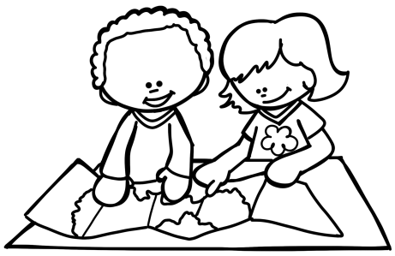
FIVE THEMES OF GEOGRAPHY
HiStory of the Five ThemeS
The five themes of geography were created in 1984 to better organize the teaching of geography, the study of Earth, in schools. There are many aspects of Earth to study since it is so large.
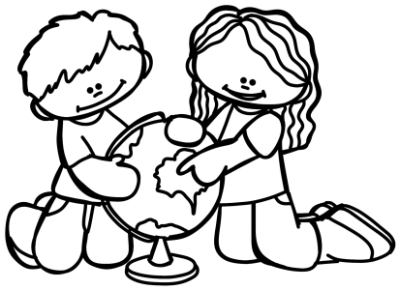
LoCation
Location tells us where we can find something on Earth. There are two types of location: absolute and relative. Absolute location is specific and uses longitude and latitude lines to describe the location of a place. Relative location tells where a place is
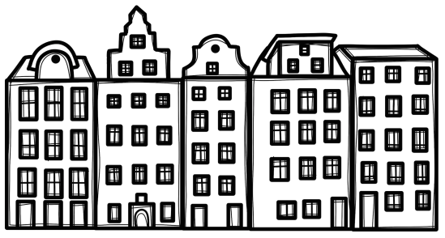
located in relation to other places.
PlaCe
Place describes the physical and human characteristics of an area distinguishing it from other places. Physical characteristics are the features and shape of the land.
Human characteristics describe the people whom live in the area.

Movement
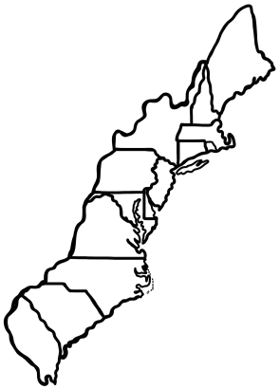
Movement refers to the way people, products, information, and ideas move from one place to another. People often move throughout their country or even to different parts of the world. Products are shipped all over the world.
Information and ideas travel quickly around the world today, especially with the internet.
Region
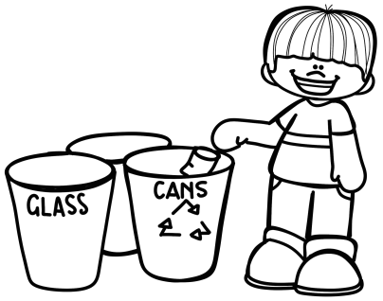
A region is defined by similar characteristics. The unifying characteristics can be physical, natural, human, or cultural.
Human Environment InteraCtion
Human-environment interaction looks at the relationships between people and their environment. It examines how people adapt to the environment and how they change it. This can be positive, like planting trees, or negative, like pollution.

Name_______________________________________
©Teaching to the Middle

FIVE THEMES OF GEOGRAPHY
WhiCh Theme?: Identify each description with the appropriate theme.
1. | The American South includes sixteen states with similar features.
2. | San Francisco, California is on a bay and is well known for its Golden Gate Bridge.
3. | New York City is found at 40 degrees north and 74 degrees west.
4. | Many people who live in Nordic countries often have  lighter skin and hair.
5. | Rock and roll music originated in the United States, but spread around the world.
6. | My school is near the town hall and police station.
7. | Many of the clothes Americans wear were made overseas.
8. | Many people in the world have seen the importance of recycling to reduce trash.
WhiCh Theme?: Identify each picture with the appropriate theme.
9. | 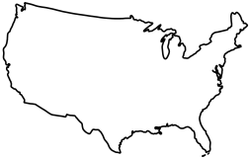
10. | 
11. | 
12. | 
13. | 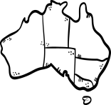

Multiple ChoiCe: Choose the best answer.
- What is the main reason the five themes of geography were created?
  - To make it easier for students to learn where things are located.
  - To better organize the teaching of geography in schools.
  - To label the seven continents and five major oceans.
  - To educate teachers on how to best teach geography.
- What is the main difference between location and place?
  - Location has two categories, while place only has one.
  - Place tells the exact location of a place using latitude and longitude.
  - Place describes the physical and human characteristics of a place,
while location tells where a place is on a map.
  - Location describes the physical and human characteristics of a place, while place tells where a location is on a map.

- What is the most likely reason ideas move quicker around the world today than in previous centuries?
  - The invention of the internet allows ideas to move much faster.
  - More people around the world are now educated.
  - Boats and cars are more advanced in today’s time.
  - Products can be made much faster today.
- Which of the following is NOT a unifying characteristic defining a region mentioned in the article?
  - Physical features, such as a mountains
  - Human features, such as language
  - Cultural features, such as religion
  - Location features, such as latitude and longitude
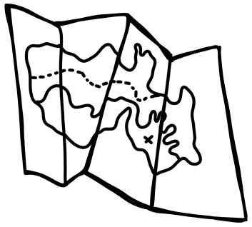
- Which of the following would be considered a negative example of human environment interaction?
  - Recycling bottles and paper at school
  - Planting trees around school
  - Leaving food wrappers outside after lunch.
  - Using reusable bags while shopping.

Name_______________________________________

FIVE THEMES OF GEOGRAPHY
DireCtionS: Choose a location anywhere in the world. Illustrate and describe each theme for that place.

LOCATION
PLACE

MOVEMENT
REGION

HUMAN ENVIRONMENT INTERACTION

