THE ENLIGHTENED DESPOTISM IN SPAIN: CARLOS III

Carlos III (1759-1788) was the greatest exponent of enlightened despotism in Spain. He promoted reforms but did not renounce his power or change the country's social structures.
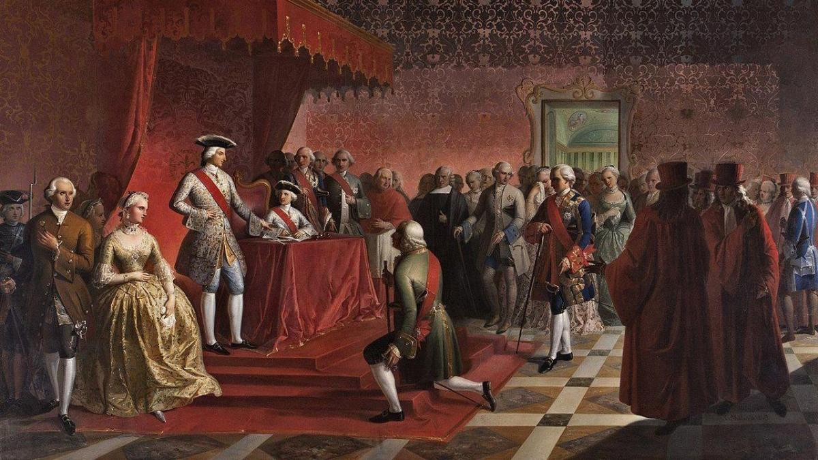

He used his experience as king of Naples and Sicily and took advice from Italian ministers, such as Esquilache, and Grimaldi, to conduct economic reforms, including the liberalization of wheat.
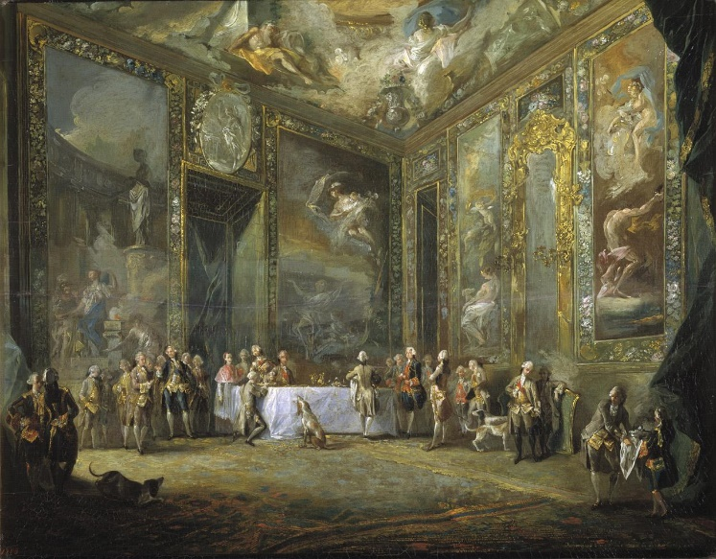
These measures were opposed by both the working classes and the privileged classes. In 1766, this opposition led to the Esquilache Riots, a popular rebellion against the high wheat prices and taxes. It was probably instigated by the nobility and clergy, whose power had decreased.

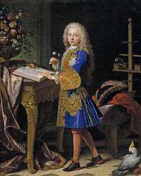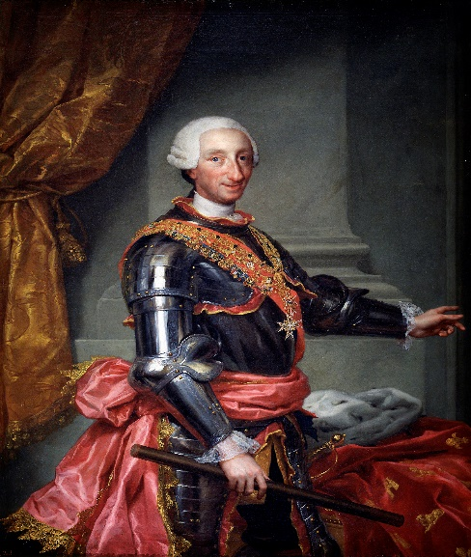

After the rebellion, politicians such as the Count of Floridablanca, the Count of Aranda and the Count of Campomanes gained significant power and promoted measures:
- The Jesuits, accused of instigating the rebellion, were expelled (1767). This increased the monarchy's power over the Church.
- New primary schools were created and university education was reformed. In addition, all professions were declared to be honest (1783).
- The privileges of the Mesta were reduced to boost agriculture and new lands were colonised in depopulated areas of Sierra Morena.
- All Spanish ports were allowed to trade with America (1778) and the National Bank of San Carlos was created.

