THE WAR OF SPANISH SUCCESSION

Charles II died childless in 1700. In his will, Philip of Anjou, Louis XIV´s grandson, was appointed as his successor. Therefore, Philip V´s reign marks the beginning of the House of Bourbon in Spain.

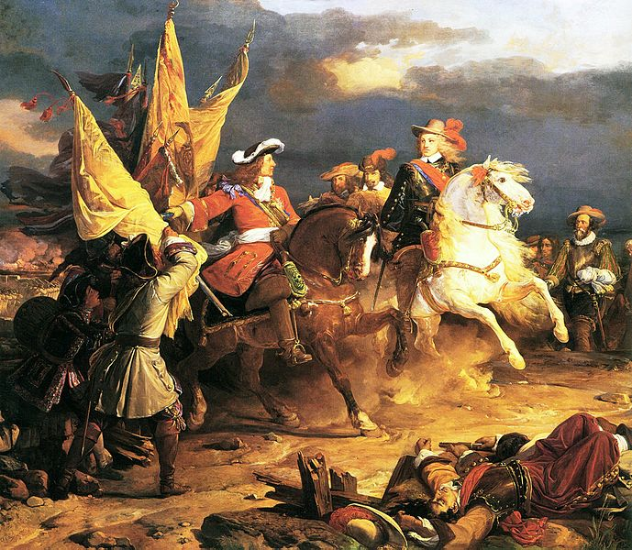
European countries felt threatened with the idea of a possible union of France and Spain, so they supported the claims of Archduke Charles of Austria to the Spanish crown.

The conflict arose and the War of Spanish Succession started.

The War of Spanish Succession had a double version:

a) It was an international conflict between France and Spain against Britain, the German Emperor, Savoy, Portugal and the United Provinces.

b) However, it also could be considered as a civil war between Castile supporting Philip of Anjou and Aragón in favor of Archduke Charles because Aragonese Cortes were against the centralist policies implemented by the Bourbons in France.

War in Europe ended around 1711 when German Emperor died and Archduke Charles was appointed his successor while the conflict in Spain finished in 1715 when Philip V defeated the Austrian army.

The results were the treaties of Utrecht (1713) and Rastatt (1714):

- Philip V was recognized king of Spain with the condition of his renouncement to French dynastic rights.

- Spain lost the Low Countries (= Flanders) which were incorporated to Austria as well as possessions in the Italian Peninsula.

- Menorca and Gibraltar were for Great Britain as well as commercial advantages in America.

